Sowing and Self Planting Machine Using ESP32

Submitted By:
Belarmino, Lyndy
Casuga, John Andrei
Levantino, Rhanzel Ken
Pascual, A-jay
Villanueva, Nelson

Project Overview

Project Description
This project develops a Smart Sowing and Self-Planting Robot powered by an ESP32 microcontroller and Internet of Things (IoT) technology to automate the planting process in small-scale farming and gardening. The robot is designed to move along planting paths, dispense seeds at controlled intervals, and cover them automatically. Sensors are integrated to measure soil moisture, distance, and environmental conditions to ensure proper planting depth and spacing. The ESP32 enables wireless connectivity, allowing users to monitor and control the robot remotely through a mobile or web interface. Planting data such as soil status and seed count can be transmitted in real time to a database for monitoring and analysis. The system reduces the need for manual labor and increases planting accuracy. Automation helps ensure consistent spacing and depth, which improves germination rates and crop yield. The project demonstrates how low-cost IoT technology can support modern agricultural practices. The robot is intended for use in school research farms, home gardens, and small agricultural plots. This highlights the potential of embedded systems and IoT in improving the agricultural efficiency and sustainability.
Problem Statement
Traditional planting method rely heavily on manual labor, which can be slow, inconsistent, and physically demanding. Farmers and gardeners require an automated solution that improves the planting accuracy while reducing the time and effort.
The study aims to address the following problems:
- Labor Intensive Planting Process
Manual sowing requires significant physical effort and time, especially when planting large areas or multiple rows.
- Inconsistent Seed Spacing and Depth
Human planting sometimes results in uneven seed distribution, affecting crop growth, nutrient competition.
- Lack of Real Time Monitoring Soil Conditions
Traditional planting does not consider real-time soil moisture or environmental conditions, which are critical for seed growth.
- Limited Adoption of Smart Agricultural Technologies
Many small farms still lack of access to affordable automated planting tools due to high costs.
- Dependence on Manual Data Recording
Planting schedules, seed usage, and soil conditions are often recorded manually, making tracking and analysis difficult.
Objectives
General Objective
To develop an IoT enabled smart sowing and self-planting robot using an ESP32 microcontroller to automate and optimize the planting process.
Specific Objectives
The study aims to achieve the following specific objectives:
- To design and develop a robotic planting system that automates seed sowing and soil covering processes.
- To improve planting accuracy by controlling seed spacing and planting depth sensors and programmed logic.
- To reduce manual labor and planting time through automated robotic movement and seed dispensing.
- To enable real-time monitoring of soil moisture and environmental conditions using IoT sensors.
- To store planting data in a centralized system for tracking, analysis, and decision-making.

Scope and Limitations
Scope of the Study
This study focuses on the design, development, and implementation of a Smart Sowing and Self-Planting Robot that automates seed planting using IoT technology. The system includes automated seed dispensing, soil covering and environmental sensing.
Specifically, the scope of the study includes the following:
- The use of IoT hardware components such as the ESP32, motors, and sensors for automated planting.
- Wireless communication for remote monitoring and control the robot.
- Development of a simple user interface for system monitoring.
- Testing and evaluation of the robot functionality, planting accuracy, and efficiency in a controlled environment.
This study is limited to demonstrating a working prototype for small scale planting applications and does not aim to replace industrial scale agricultural machinery.
Limitations of the Study
Despite its intended functionality, the proposed system has several limitations that should acknowledged.
Specifically, the limitations of the study include the following:
- First, the system is designed for small-scale planting areas and may not be suitable for large commercial farms.
- Second, it only focuses on the seed planting and does not include full crop management features such as fertilizing, irrigation, or harvesting.
- Third, it operates best on relatively even soil, rough or rocky soil may affect movement and planting accuracy.
System Architecture
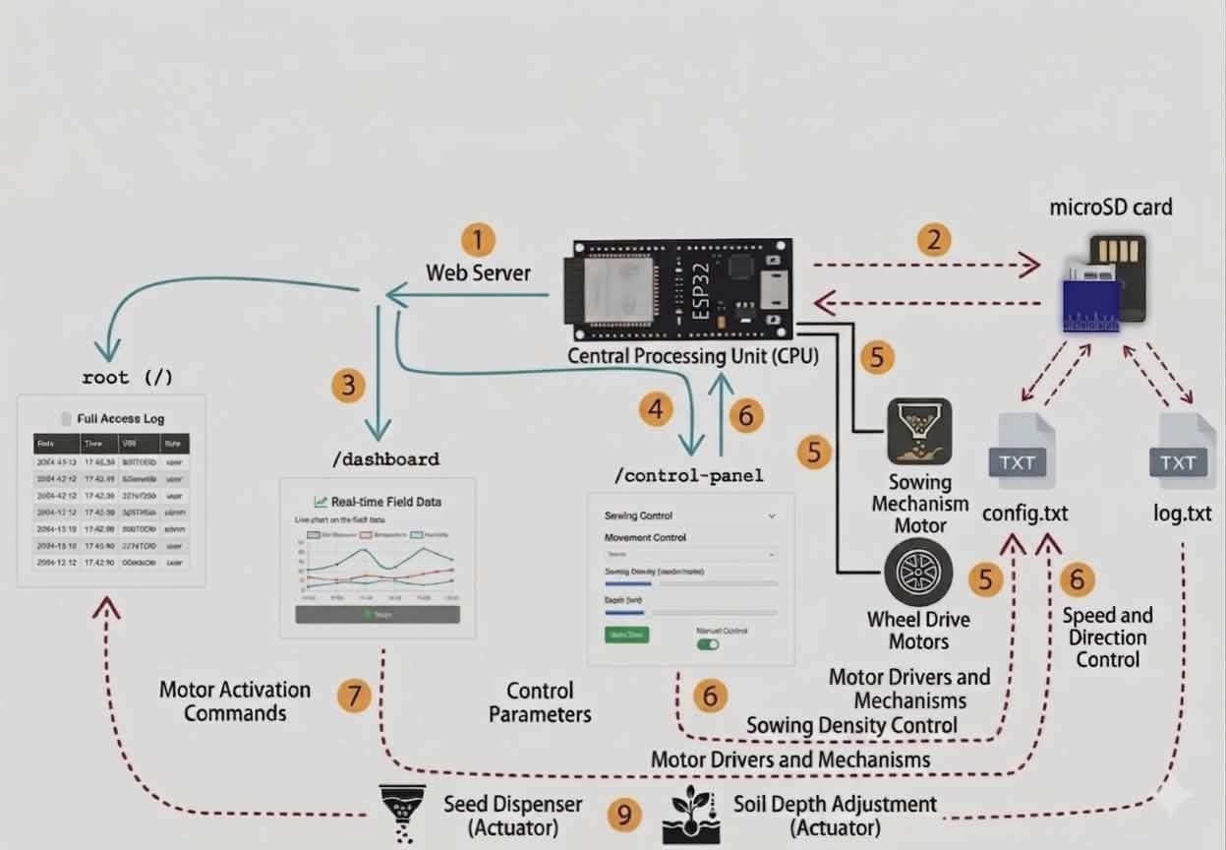

Figure 1. System Architecture
Architecture Description
The system architecture illustrates the interaction between ESP32 microcontroller, sensors, actuators, and a web server to plant the seeds automatically.
- Saving Information
It uses a microSD Card to save the two files:
- planting_log – a list of where and when seeds were planted.
- settings – saves your choices for seed depth and spacing.
- Web Control Interface
The ESP32 along host a web server so users can monitor and control the robot from a phone or computer. The website includes dashboard for the field data, a control panel for sowing commands. This makes it easier to operate and allows real-time monitoring of the important data.
- Actuation and Movement
After processing the input, the ESP32 sends commands to the wheel drive motors and sowing mechanism. The wheel motors will move along the field, while the sowing motor releases seeds at the correct spacing and depth. This closed loop process helps the robot perform automated planting accurately.
- Data Synchronization
The systems keep the web dashboard, sd card records, and live sensor reading synchronized. This ensures that the displayed information matches the actual activity and stored records. Because of this, the system remains reliable and easier to track during operation.
Sensors inputs from the soil moisture sensor, ultrasonic sensor, and IR sensors are collected by the ESP32, which processes the data to control the robot movement and sowing mechanism. The ESP32 stores planting logs and settings in the microSD card, while also hosting a web interface for monitoring user control.
Data Flow
The data shows how information moves from sensors to processing, storage, and display. This process helps make correct decisions and ensure accurate and real operation.
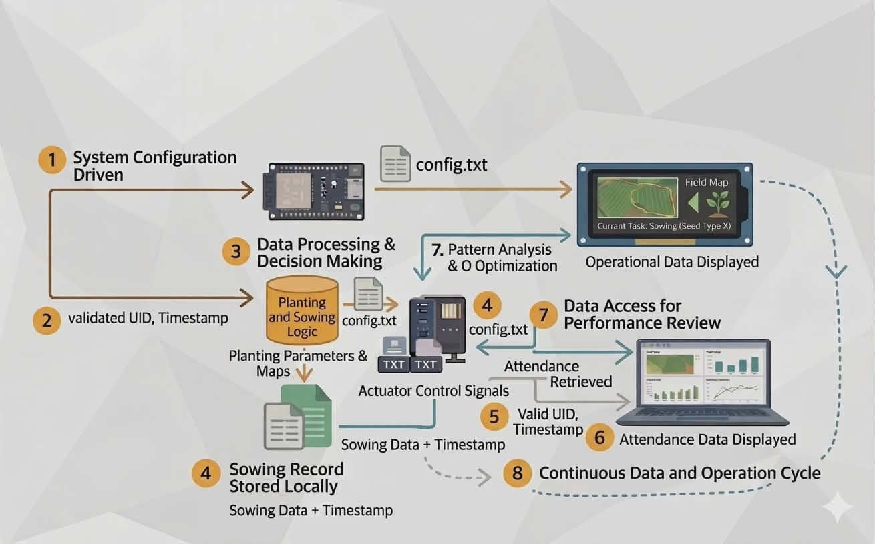

Figure 2: Data Flow
- Data transmission to the ESP32
The collected data is sent to the ESP32 microcontroller. This serves as the main controller of the robot. At this stage, the data is raw and not yet processed.
- Data Processing and decision making
The ESP32 process the sensor data and decides what action to take. It uses programmed logic such as:
- Checking if the soil is ready for planting
- Detecting obstacles using distance
- Adjusting based on temperature and humidity
- Sowing data Storage
Once the decision is made, the system records the operation. The data stored include:
- Sowing activity
- Location or pattern
- Date and time
- Onboard Display
This will show the most important information on the lcd screen, such as:
- Current task
- System status
- Field map or position
- Data access for Monitoring
The stored data can be accessed using a computer or external device. The users can view the sowing records, performance data, and the activity logs of it.
- Patterns Analysis and Optimization
The system analyses collected data that will help to improve the performance. It can adjust the planting patterns, helps improve efficiency, and optimize the future operations.
Hardware Components
Component | Description | Minimum Requirements | Recommended Requirements
Microcontroller | Main Processing unit with WiFi | ESP32 | ESP32-WROOM-32
Motor Driver | Controls chassis DC motors | L298N Dual H-Bridge | BTS 7960
DC Motors | Robot chassis propulsion | 12V 120w geared motors | 12v 120w DC motor
Servo Motors | Seed dispenser & soil tools | SG90 Micro Servo | MG996R metal gear x2
Resistor | Path following | LM2596 DC DC Step Down Converter | LM2596 DC DC Step Down Converter
Table 1. Hardware Components
Software Components
Software | Purpose | Minimum Requirements | Recommended requirements
Arduino IDE | Firmware development | v2.0+ with ESP32 board | v2.3.2 + PlatformIO
ESP32 Core | Microcontroller libraries | Arduino-ESP32 2.0 | Arduino-ESP32 3.0
Web Server | Embedded dashboard | ESPAsyncWebServer | + AsyncTCP
Data Storage | Local file system | SPIFFS | SD Library
Motor Control | PWM & direction | ESP32 servo | AccelStepper
Table 2. Software Requirements

Functional Requirements
This section defines the Smart Sowing Robot must perform for automated planting operations.
- The system shall detect planting paths
Line following DHT11 sensors identify predefined paths marked on soil. The robot maintains ±2cm accuracy while following rows at 10cm/s speed.
- The system shall maintain precise seed spacing
Ultrasonic sensor enforces 5-20cm (configurable) intervals between seeds. Motor control pauses movement for accurate positioning.
- The system shall execute automated planting cycles
Complete sequence: advance – dig hole 2-5 cm – dispense 1-2 seeds – cover soil – log event.
- The system shall provide real-time web dashboard
ESP32 web server displays live data: position, seed count, battery status.
- The system shall provide store planting records locally
MicroSD card logs each planting event with timestamp, row/position, moisture, outcome.
Non-Functional Requirements
These define quality attributes ensuring reliable field operation.
- Usability
Web dashboard accessible without app installation. Configuration via simple web forms. Status LEDs for visual feedback (ready, planting, error).
- Reliability
Its planting success rate or the proper depth spacing is about 90%. Making sure the data integrity is maintain through checksums.
- Performance
Complete the planting cycle execute in 8 seconds. The sensor response time is for about 100ms. Supports continuous operation for 30 minutes.
- Power Efficiency
Autonomous mode <2W average draw. Battery life >90 minutes continuous planting.

Database Design
Field | Description
planting_id | Unique sequential identifier for each planting event
timestamp | Date and time of planting (YYYY-MM-DD HH:MM:SS)
row_number | Current planting row (1-99)
position_cm | Distance along row in centimeters (0-9999)
soil_moisture | Soil moisture percentage at planting (0-100%)
planting_depth | Measured depth of seed placement (cm, 0.5-5.0)
seeds_planted | Number of seeds dispensed (1-3)
status | Outcome: OK, DRY_SOIL, OBSTACLE, ERROR
battery_voltage | System battery level (V, 6.0-12.0)
temperature | Air temperature (°C)
humidity | Relative humidity (%)

System Operation Procedure
This section describes the step-by -step procedure for operating it. The procedures outlines then normal sequence of actions required to ensure proper system functionality from device startup to planting operations.
Step 1. Power on the Machine
Power on the Machine

The machine is powered on using the main power switch. The ESP32 initializes all hardware components including the motors, sensors, servos, microSD storage, and wifi module.
Step 2. Establish Wi-Fi Connection
Establish Wi-Fi Connection

The ESP32 automatically connects to the configure Wi-Fi network or creates a captive portal. Users connect via smartphone/laptop browser to access the web dashboard. Successful connection sows Wi-Fi connected at dashboard.
Step 3. Place Machine on starting position
Place Machine on Starting Position

Manually place robot at the start of the marked planting path. Ensure seed hopper contains seed and the battery at >30%. Web dashboard confirms Ready to plant status with all the sensors calibrated.
Step 4. Autonomous Planting Initiation
Autonomous Planting Initiation

Access web dashboard – planting control page – click start. Robot Begins:
- IR sensors detect path line
- Soil moisture sensor validates planting conditions
- Ultrasonic sensor confirms clear ahead.System Status changes to “Planting Active”
Step 5. Planting Cycle Execution
Automated Planting Sequence

Robots execute complete planting cycle:
- Advance: Motors move 10cm along path (IR guided)
- Soil Check: Moisture sensor validates (>30% required)
- Dig: Servo auger creates 2cm deep hole
- Dispense: Seed hopper servo drops 1-2 seeds
- Cover: covering arm fills hole with soil
- Log: Event recorder to microSD with timestamp/moisture cycle repeats until row end or STOP command

Gantt Chart (Ajay Pascual)
Task / Phase | Week 1 | 2 | 3 | 4 | 5 | 6 | 7 | 8
Project Planning & Proposal | ███ | ███
Requirements Analysis |  | ███
System Architecture Design |  | ███
Hardware Setup & Wiring |  | ███ | ███
Firmware Development (ESP32) |  |  |  | ███
Web Server & Dashboard Development |  |  |  |  |  |  | ███
Data Storage Configuration |  |  |  | ███ |  |  | ███
System Integration |  |  |  |  |  |  | ███
Testing & Debugging |  |  |  |  |  | ███ |  | ███
Documentation Writing |  | ███ | ███ | ███ |  |  | ███ | ███
Final Evaluation & Submission |  |  |  |  |  |  |  | ███

Gantt Chart ( Belarmino, Lyndy)
Task / Phase | Week 1 | 2 | 3 | 4 | 5 | 6 | 7 | 8
Project Planning & Proposal | ███ | ███
Requirements Analysis |  | ███
System Architecture Design |  | ███
Hardware Setup & Wiring |  |  |  | ███ |  |  | ███
Firmware Development (ESP32) |  |  |  | ███ |  |  | ███
Web Server & Dashboard Development |  |  |  | ███ |  |  | ███
Data Storage Configuration |  |  |  | ███
System Integration |  |  |  |  | ███ |  | ███
Testing & Debugging |  |  |  |  |  |  | ███ | ███
Documentation Writing | ███ | ███ | ███ | ███ | ███ |  | ███
Final Evaluation & Submission |  |  |  |  |  |  |  | ███

Gantt Chart (Levantino, Rhanzel Ken)
Task / Phase | Week 1 | 2 | 3 | 4 | 5 | 6 | 7 | 8
Project Planning & Proposal | ███ | ███
Requirements Analysis |  | ███
System Architecture Design |  | ███
Hardware Setup & Wiring |  |  | ███ |  |  |  | ███ | ███
Firmware Development (ESP32) |  |  |  | ███
Web Server & Dashboard Development
Data Storage Configuration
System Integration |  |  |  | ███ |  |  |  | ███
Testing & Debugging |  |  |  |  |  |  | ███ | ███
Documentation Writing
Final Evaluation & Submission |  |  |  |  |  |  |  | ███

Gantt Chart (Villanueva, Nelson)
Task / Phase | Week 1 | 2 | 3 | 4 | 5 | 6 | 7 | 8
Project Planning & Proposal | ███ | ███
Requirements Analysis |  | ███
System Architecture Design |  | ███
Hardware Setup & Wiring |  |  | ███ |  |  |  |  | ███
Firmware Development (ESP32) |  |  |  | ███ |  |  |  | ███
Web Server & Dashboard Development |  |  |  | ███
Data Storage Configuration |  |  |  |  |  | ███
System Integration |  |  |  | ███ |  |  |  | ███
Testing & Debugging |  |  |  |  |  | ███ | ███ | ███
Documentation Writing |  |  |  |  |  |  |  | ███
Final Evaluation & Submission

Gantt Chart (Casuga, John Andrei)
Task / Phase | Week 1 | 2 | 3 | 4 | 5 | 6 | 7 | 8
Project Planning & Proposal | ███ | ███
Requirements Analysis |  | ███
System Architecture Design |  | ███
Hardware Setup & Wiring |  |  | ███
Firmware Development (ESP32) |  |  | ███ | ███
RFID Integration |  |  |  |  | ███
Web Server & Dashboard Development |  |  |  | ███
Data Storage Configuration |  |  |  |  |  | ███
System Integration |  |  |  |  |  | ███
Testing & Debugging |  |  |  |  |  |  | ███ | ███
Documentation Writing |  |  |  |  |  |  |  | ███
Final Evaluation & Submission |  |  |  |  |  |  |  | ███

Expected Output
The expected output of the Smart Sowing and Self-Planting Robot are the following:
- Automated Seed Sowing
The system automatically dispenses seed at precise 5-20cm interval and 2-5cm depths using servo motors and sensors, ensuring consistent spacing and coverage to improve germination rates.
- Path-following navigation
IR line sensors guide the robot along predefined planting paths with 2cm accuracy at 10cm/s speed, enabling autonomous movement across small scale plots without manual intervention.
- Real-time Environmental Monitoring
Soil moisture, ultrasonic distance, temperature, and humidity data from sensors are processed instantly by the ESP32, displayed line by the web dashboard for optimal planting decisions.
- Centralized Planting Logs
All planting events and including timestamp, row position, soil conditions, seed count, and status are stored in a microSD card in a structured database for tracking and analysis.
- Web-Based Control Dashboard
A responsive web interface hosted by the ESP32 allows remote monitoring in the status, live sensor data, and manual controls via any browser on phones or computers.
- Reliable Field Operation
The prototype achieves 90% planting success rate with 8 seconds cycle times, 30 minutes battery life, and obstacle detection for safe operation in home gardens or school farms.
Development Period
The development period refers to the time that is spent during the system was designed, build, programmed, tested and finalized. For this project, the development covers 8 weeks, starting from the planning of the project up to the final evaluation and documentation.

Pictures During Development (Documentation Evidence)
The pictures serve as a visual proof of system development and implementation. This image is captured during the actual development.
The first week focused on planning the Sowing and Self-Planting Machine using ESP32. The researchers identified the needed materials, system functions, and machine workflow. Initial sketches and 3D models were created to visualize the structure, component placement, and overall design before actual development.
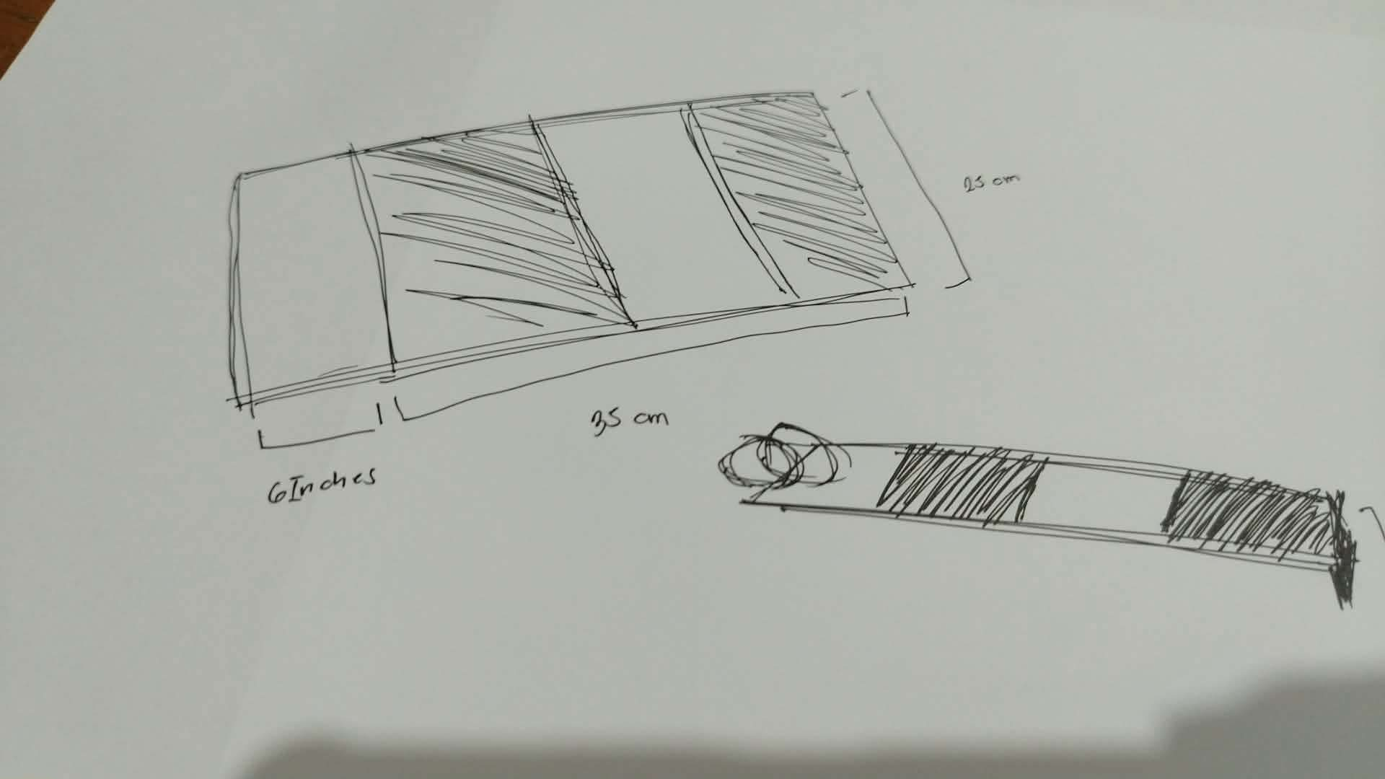
During the second week, the project design was improved through remodeling and design adjustments. The researchers enhanced the machine’s balance, structure, and functionality. A more detailed 3D model was also developed to examine the dimensions, alignment, and arrangement of components before fabrication.

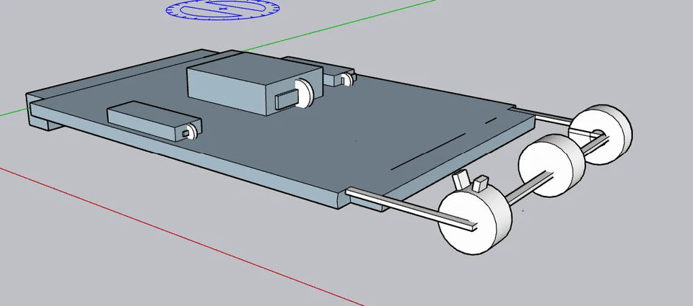
The third week focused on purchasing the required materials and refining the machine’s design. The team reviewed the original plan, improved the structure, and updated the sketches to create a more organized and efficient automated planting system.
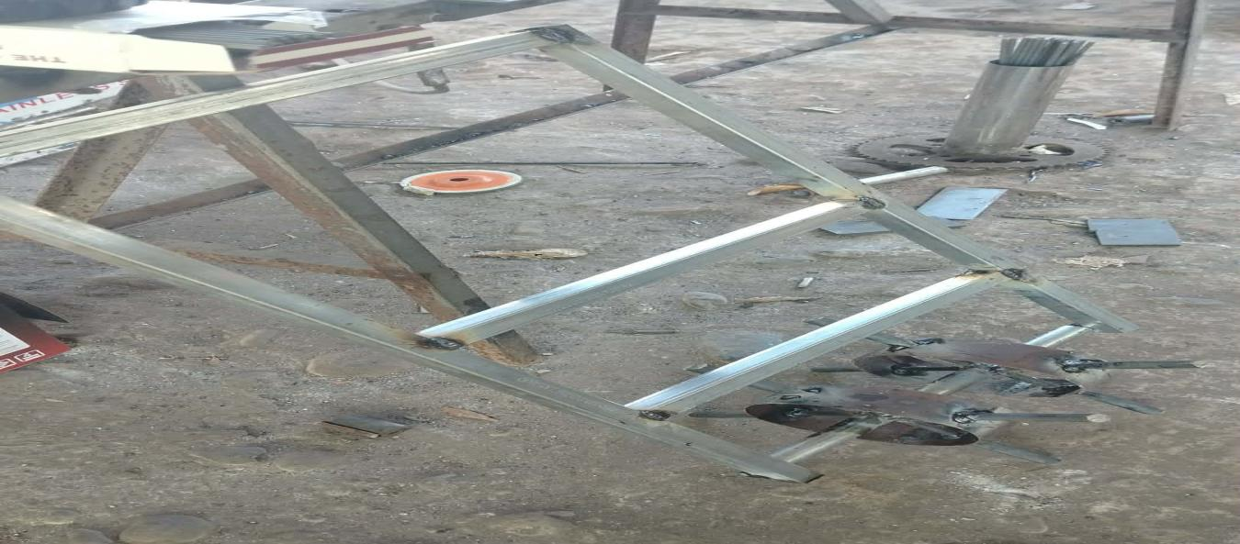

During the fourth week, the main frame of the machine was built using a metal tubular structure. The researchers carefully assembled and measured the frame to ensure stability, durability, and proper component placement for future installation of electronic and mechanical parts.
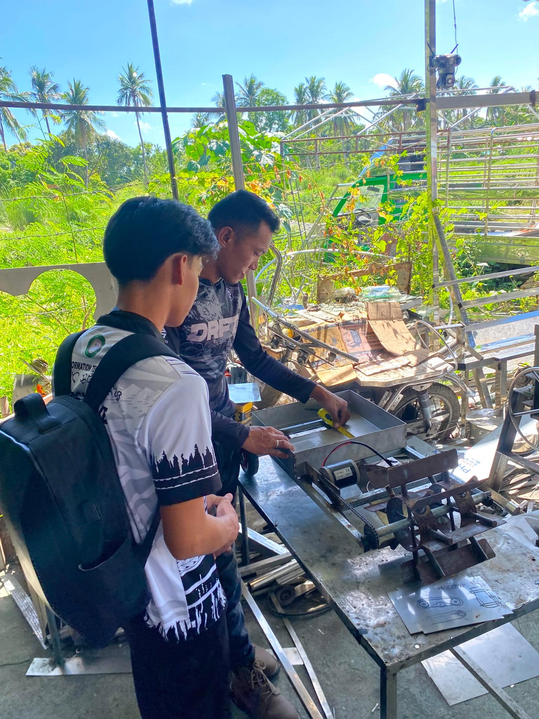
The fifth week focused on improving and upgrading the machine’s structure. Adjustments were made to the placement of motors, wheels, and wiring to enhance balance, durability, and overall performance. The remodeling process also helped prepare the machine for system installation and testing.
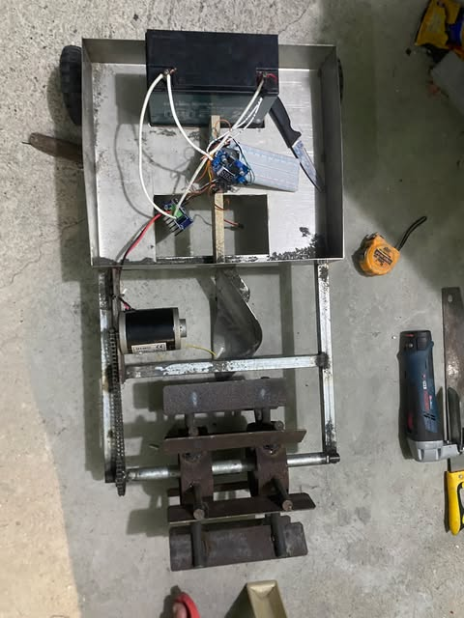

Figure 3. Development Period

